Chapter 11, Solution 7.

Given the circuit of Fig. 11.40, find the average power absorbed by the 10-Ω resistor.

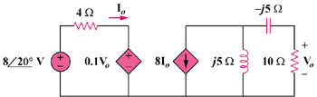

Figure 11.40
For Prob. 11.7.

Solution

Applying KVL to the left-hand side of the circuit,
(1)

Applying KCL to the right side of the circuit,
But,
Hence,
(2)

Substituting (2) into (1),

160W

